**CHAPTER 1**

**INTRODUCTION**

The purpose of Online Local Store is to automate the existing manual system by the help of full-fledged computer software, fulfilling their requirements, so that their valuable data information can be stored for a longer period with easy accessing and manipulation of the same. The required software and hardware are easily available and easy to work with Online Local Store, as described above, can lead to error free, secure, reliable and fast management system. It can assist the user to concentrate on their other activities rather to concentrate on the record keeping. Thus it will help organization in better utilization of resources. The organization can maintain computerized records without redundant entries. That means that one need not be distracted by information that is not relevant, while being able to reach the information. Basically the project describes how to manage for good performance and better services for the clients.

The main objective of Online Local Store is to manage the information about Products, Customer Details, Purchase History, Stock Details etc. The project is totally built at administrative end and thus only the administrator is guaranteed the access to database. The purpose of the project is to build an application program to reduce the manual work for managing the Order, Stock, Product Order, Purchase history.

**1.2 STATEMENT OF THE PROBLEM**

As we step forward into the modern era of technology, we may find many engineering related applications very beneficial for improvements into the society. This is the world of technology where people use smart phones for completing their daily tasks like shopping, paying bills, managing work and much more. The idea of this project is to add its features into the lives of the people so that the food products which they buy, can be bought directly from the store so that they don’t have to wait in long queue.The store will be dealing with the customer directly so the prices of the products offered by the farmer to the customer will also be affordable to customer, which will help both the store and the customer where the customer can save some money and the store can sell there products more faster.

**CHAPTER 2**

**SYSTEM ANALYSIS**

**2.1 Present system**

There is no computerized system for the store to sell their product. Currently, the customer goes to nearest shop , buys his product from a particular shop.

Customer has to wait in along queue sometime if it’s peak hours. If the product he/she searching for if unavailable , he/she has to search all the near by stores for the same until he/she finds what he/she need. This is very time consuming. Sometime it may even lead to money and man power loss.

**2.2 Limitation of present system**

1. Manual process
2. Time Consuming
3. More human effforts needed

**2.3 Proposed system**

Online Local Store software features are designed to emulate many of the marketing activities involved with local shops. The software’s online ordering capabilities and reporting forms facilitate easy purchasing of products from near by shops that are registered within the system. The software supports up to two separate marketplace accounts for shop owners and customers. Markets can accept home delivery and customer pickup delivery. All payments done on the delivery day.

**2.4 Advantages and features of proposed system**

1. Fully Automated
2. Easy product searching
3. Faster
4. Less human effort needed

**2.5 Feasibility Study**

A feasibility study is an analysis of how successfully a project can be completed, accounting for factors that affect it such as technical, economic, behavioral, operational factors. When a new project is proposed, it normally goes through the feasibility assessment. Feasibility Study is carried out to determine whether the proposed system is possible to develop with available resources & what should be the cost of consideration.

Various types of feasibilities are,

1. Technical Feasibility
2. Economic Feasibility
3. Operational Feasibility

If the proposed system is not feasible to develop, it is rejected at this very step.

**2.5 .1 Technical Feasibility**

The proposed system uses the language Python. Based on this criteria, we can strongly say that it is technically feasible, since there will not be much difficulty in getting required resources for the development & maintaining system as well. All the resources needed for the development of the software as well as the maintenance of the same is available in the organization. Here we are utilizing the resources which are already available so it’s very well technically feasible that we can implement flood detection system.

**2.5 .2 Economic Feasibility**

It is found that the benefit from our system would be more than the cost and time involved in its development. In our system the implementation cost over production is economically feasible. Economic analysis is the most frequently used techniques for evaluating the effectiveness of the proposed system more commonly known as cost/benefit analysis the procedure is to determine the benefits and savings that are expected from a proposed system and compare them with costs.

**2.5 .3 Operational Feasibility**

The proposed system satisfies operational feasibility in the way that the customers needs are satisfied. The system is adaptable to the customers and acceptable to the common people who use this. Operational feasibility assesses the extent to which the required software performs a series of steps to solve business problems and user requirements. This feasibility is dependent on human resources (software development team) and involves visualizing whether the software will operate after it is developed and be operative once it is installed. Operational feasibility also performs the following tasks:

1. Determines whether the problems anticipated in user requirements are of high priority
2. Determines whether the solution suggested by the software development team is acceptable
3. Analyses whether users will adapt to a new software
4. whether the organization is satisfied by the alternative solutions proposed by the software development team.

**CHAPTER 3**

**SYSTEM SPECIFICATION**

**3.1 Software Requirements**

1. Operating System : Windows 8/10

2. Language : Python

3. Framework : Django

4. IDE : Visual Studio Code

**3.2 Hardware Requirements**

1. Processor : Intel i3 or AMD Ryzen 3

2. RAM : 3 GB

3. Hard Disk Drive : 200 GB

4. Peripherals : Keyboard, Mouse, Monitor, Camera

**CHAPTER 4**

**SYSTEM DESIGN**

**4.1 Context Level Diagram**



Fig 4.1 Context Level Diagram

**4.2 Data Flow Diagram**



Fig 4.2.1 Level 1 DFD of Online Local Store



Fig 4.2.2 Level 2 DFD of Admin



Fig 4.2.3 Level 2 DFD of Store



Fig 4.2.4 Level 2 DFD of Public

**4.3 ER-Diagram**



**4.4 Database Design**

Table products

Field Name Data type Size Constraints Description

Id IntegerField PrimaryKey

Pname CharField 100 Not NULL

Ptype CharField 10 Default

Description TextField Not NULL

Stock IntegerField Not NULL

price IntegerField Not NULL

img1 ImageField Not NULL

img2 ImageField Not NULL

img3 ImageField Not NULL

offer BooleanField Default

isactive BooleanField Default

offerprice IntegerField Default

created_at DateField Not NULL

owner IntegerField Foreign key

Table cart

Field Name Data type Size Constraints Description

Id IntegerField PrimaryKey

userid IntegerField Foreign key

productid IntegerField Foreign key

quantity IntegerField Default

Table user

Field Name Data type Size Constraints Description

Id IntegerField PrimaryKey

Password CharField 128 Not NULL

last_login DateField 10

is_superuser BooleanField Not NULL

username CharField 150 Not NULL

first_name CharField 30 Not NULL

last_name CharField 150 Not NULL

email CharField 254 Not NULL

is_staff BooleanField Not NULL

is_active BooleanField Not NULL

date_joined DateField Not NULL

Table userProfile

Field Name Data type Size Constraints Description

Id IntegerField PrimaryKey

state CharField 200 Not NULL

shopname CharField 200 Not NULL

house CharField 200 Not NULL

town CharField 200 Not NULL

address CharField 200 Not NULL

pincode CharField 12 Not NULL

phone CharField 12 Not NULL

isstore BooleanField Not NULL

description CharField 200 Not NULL

img ImageField Not NULL

isactive BooleanField Not NULL

license_no CharField 20 Not NULL

user IntegerField Foreign key

Table orderDetails

Field Name Data type Size Constraints Description

Id IntegerField PrimaryKey

userid IntegerField Foreign key

productid IntegerField Foreign key

quantity IntegerField Not NULL

date DateField Not NULL

address CharField Not NULL

status BooleanField Default

paymode CharField 20 Default

Table reviewDetails

Field Name Data type Size Constraints Description

Id IntegerField PrimaryKey

userid IntegerField Foreign key

productid IntegerField Foreign key

stars IntegerField Default

review CharField 200 Default

**4.5 Normalization**

Designing a data base is a complex task and the normalization theory is a useful and in this design process.

A bad database design may lead to certain undesirable situations such as;

1. Repetition of information
2. Inability to represent certain information
3. Loss of information

To minimize the anomalies, normalization may be used. In construction and system, here

there is only one database named result. There are tables in database.

**First Normal form (1 NF)**

A relation is in first normal form (1 NF), if and only if all its attributes are based on a single domain. The objective of normalizing a table is to remove its repeating groups and ensure that all entries of the resulting table have at most single value. The objective of 1NF is to divide the database into logical units called tables. When each table has been designed, primary key is assigned to most or all tables.

**Second Normal form** (2 NF)

A table is said to be in second normal form (2 NF), when it is in 1NF and it satisfies functional dependency. Functional of 2NF is to take data that is partially dependent on the primary key, enter the data into another table. Now consider the data base of the system. In this there are a total of table and all tables are in second normal form. That is all of these tables satisfies second normal form. No repeated information is stored in any table. All of the table. All of the tables have a separate primary key some of all are auto numbers.

**Third Normal form (3 NF)**

A table is said to be in 3NF, when it is 2NF and every non-key attribute is functionally

dependent only on the primary key. The objective of 3NF is to remove data in a table that is not dependent on the primary key.

All our tables are in First normalization form

**Benefits of Normalization**

1. To permit simple retrieval of data in response to query and report requests.
2. Helps to simplify the structure of tables.
3. To structure the data so that there is no repletion of data, that helps in saving space.
4. To simplify the maintenance of data through updates, insertions and deletions.
5. To reduce the need to restructure data when new applications requirements arise.
6. Data consistency within the database.
7. Much more flexible database design.
8. A better handle on database security.
9. Index searching is often faster, since indexes tend to be narrower and shorter.
10. More tables allow better use of segments to control physical placement of data.
11. Fewer null values and less redundant data, making your database more compact.
12. Triggers execute more quickly if you are not maintaining redundant data.

**4.6 Design of Each Subsystem**



Fig 4.3 Subsystem Design

**4.7 UML Diagrams**

**4.7.1 Use case Diagram**



Fig 4.4.1 Use case Diagram

**4.7.2 Sequence Diagram**



Fig 4.4.2 Sequence Diagram

**CHAPTER 5**

**CODING**

**5.1 Features of Language**

**Python Overview**

Python is a general-purpose, interpreted, high-level programming language which is widely used nowadays .It is an open source language which was developed by Guido Van Rossum in the late 1980s .Python Software Foundation (PSF), a non-profit organization, holds the intellectual property rights of Python. Python was released in 1991 at Centrum Wiskunde & Informatica (CWI) in the Netherlands as a successor to the ABC language. Rossum named this language after a popular comedy show called 'Monty Python's Flying Circus' (and not after Python-the snake).In the last few years, the popularity of python has increased immensely due to its wide applications. According to most of the tech surveys, Python is in the top ten Most Popular Technologies in 2019.

**Python Features**

Python is an interpreter-based language, which allows execution of one instruction at a time.

1. Extensive basic data types are supported e.g. numbers (floating point, complex, and unlimited-length long integers), strings (both ASCII and Unicode), lists, and dictionaries.
2. Variables can be strongly typed as well as dynamic typed.
3. Supports object-oriented programming concepts such as class, inheritance, objects, module, namespace etc.
4. Cleaner exception handling support.
5. Supports automatic memory management.

**Python Advantages**

1. Python provides enhanced readability. For that purpose, uniform indents are used to delimit blocks of statements instead of curly brackets, like in many languages such as C, C++ and Java.
2. Python is free and distributed as open-source software. A large programming community is actively involved in the development and support of Python libraries for various applications such as web frameworks, mathematical computing and data science.
3. Python is a cross-platform language. It works equally on different OS platforms like Windows, Linux, Mac OSX etc. Hence Python applications can be easily ported across OS platforms.
4. Python supports multiple programming paradigms including imperative, procedural, object-oriented and functional programming styles.
5. Python is an extensible language. Additional functionality (other than what is provided in the core language) can be made available through modules and packages written in other languages (C, C++, Java etc)
6. A standard DB-API for database connectivity has been defined in Python. It can be enabled using any data source (Oracle, MySQL, SQLite etc.) as a backend to the Python program for storage, retrieval and processing of data.
7. Standard distribution of Python contains the Tkinter GUI toolkit, which is the implementation of popular GUI library called Tcl/Tk. An attractive GUI can be constructed using Tkinter. Many other GUI libraries like Qt, GTK, WxWidgets etc. are also ported to Python.
8. Python can be integrated with other popular programming technologies like C, C++, Java, ActiveX and CORBA.

**Django**

Django is a high-level Python Web framework that encourages rapid development and clean, pragmatic design. Built by experienced developers, it takes care of much of the hassle of Web development, so you can focus on writing your app without needing to reinvent the wheel. It’s free and open source.

**Django Features**

**Ridiculously fast**:- Django was designed to help developers take applications from concept to completion as quickly as possible.

**Fully loaded**:- Django includes dozens of extras you can use to handle common Web development tasks. Django takes care of user authentication, content administration, site maps, RSS feeds, and many more tasks — right out of the box.

**Reassuringly secure**:- Django takes security seriously and helps developers avoid many common security mistakes, such as SQL injection, cross-site scripting, cross-site request forgery and clickjacking. Its user authentication system provides a secure way to manage user accounts and passwords.

**Exceedingly scalable**:- Some of the busiest sites on the planet use Django’s ability to quickly and flexibly scale to meet the heaviest traffic demands.

**Incredibly versatile**:- Companies, organizations and governments have used Django to build all sorts of things — from content management systems to social networks to scientific computing platforms.

**5.2 Functional Description**

**# Settings.py**

"""

Django settings for OnlineLocalStore project.

Generated by 'django-admin startproject' using Django 3.0.5.

For more information on this file, see

https://docs.djangoproject.com/en/3.0/topics/settings/

For the full list of settings and their values, see

https://docs.djangoproject.com/en/3.0/ref/settings/

"""

import os

# Build paths inside the project like this: os.path.join(BASE_DIR, ...)

BASE_DIR = os.path.dirname(os.path.dirname(os.path.abspath(__file__)))

# Quick-start development settings - unsuitable for production

# See https://docs.djangoproject.com/en/3.0/howto/deployment/checklist/

# SECURITY WARNING: keep the secret key used in production secret!

SECRET_KEY = '2l@+hr+dyz*e^ti7f12cwefkl2ogk1^k7uc@+=3-dlb=o&0)$9'

# SECURITY WARNING: don't run with debug turned on in production!

DEBUG = True

ALLOWED_HOSTS = ['*']

# Application definition

INSTALLED_APPS = [

'shop.apps.ShopConfig',

'localShop.apps.LocalshopConfig',

'django.contrib.admin',

'django.contrib.auth',

'django.contrib.contenttypes',

'django.contrib.sessions',

'django.contrib.messages',

'django.contrib.staticfiles',

]

MIDDLEWARE = [

'django.middleware.security.SecurityMiddleware',

'django.contrib.sessions.middleware.SessionMiddleware',

'django.middleware.common.CommonMiddleware',

'django.middleware.csrf.CsrfViewMiddleware',

'django.contrib.auth.middleware.AuthenticationMiddleware',

'django.contrib.messages.middleware.MessageMiddleware',

'django.middleware.clickjacking.XFrameOptionsMiddleware',

]

ROOT_URLCONF = 'OnlineLocalStore.urls'

TEMPLATES = [

{

'BACKEND': 'django.template.backends.django.DjangoTemplates',

'DIRS': [os.path.join(BASE_DIR,'template')],

'APP_DIRS': True,

'OPTIONS': {

'context_processors': [

'django.template.context_processors.debug',

'django.template.context_processors.request',

'django.contrib.auth.context_processors.auth',

'django.contrib.messages.context_processors.messages',

],

},

},

]

WSGI_APPLICATION = 'OnlineLocalStore.wsgi.application'

# Database

# https://docs.djangoproject.com/en/3.0/ref/settings/#databases

DATABASES = {

'default': {

'ENGINE': 'django.db.backends.sqlite3',

'NAME': os.path.join(BASE_DIR, 'db.sqlite3'),

}

}

# Password validation

# https://docs.djangoproject.com/en/3.0/ref/settings/#auth-password-validators

AUTH_PASSWORD_VALIDATORS = [

{

'NAME': 'django.contrib.auth.password_validation.UserAttributeSimilarityValidator',

},

{

'NAME': 'django.contrib.auth.password_validation.MinimumLengthValidator',

},

{

'NAME': 'django.contrib.auth.password_validation.CommonPasswordValidator',

},

{

'NAME': 'django.contrib.auth.password_validation.NumericPasswordValidator',

},

]

# Internationalization

# https://docs.djangoproject.com/en/3.0/topics/i18n/

LANGUAGE_CODE = 'en-us'

TIME_ZONE = 'UTC'

USE_I18N = True

USE_L10N = True

USE_TZ = True

# Static files (CSS, JavaScript, Images)

# https://docs.djangoproject.com/en/3.0/howto/static-files/

STATIC_URL = '/static2/'

STATICFILES_DIRS = [

os.path.join(BASE_DIR,'static')

]

STATIC_ROOT = os.path.join(BASE_DIR,'assets')

MEDIA_ROOT= os.path.join(BASE_DIR, 'media')

MEDIA_URL= "/media/"

**# urls.py**

from django.urls import path

from . import views

from django.conf.urls import url

urlpatterns = [

path('', views.index,name='index'),

path('logout', views.logout,name='user_logout'),

path('login', views.login,name='user_login'),

path('signup', views.signup,name='user_signup'),

path('search', views.search,name='product_search'),

path('single', views.single,name='product_single'),

path('checkout', views.checkout,name='checkout'),

path('orderstatus', views.orderstatus,name='order_status'),

path('viewcart', views.viewcart,name='cart_status'),

path('addtocart', views.addtocart, name='cart_create'),

path('removefromcart', views.removefromcart, name='removefromcart'),

path('shopsnearme', views.shopsnearme, name='shopsnearme'),

path('orderhistory', views.orderhistory, name='order_history'),

path('shopproducts', views.shopproducts, name='shopproducts'),

path('addreview', views.addreview,name='add_review'),

url(r'^ajax/autocomplete/$', views.autocomplete, name='ajax_autocomplete'),

path('contact', views.contact,name='contact')

]

**# views.py**

from django.shortcuts import render, redirect

from django.contrib.auth.models import User, auth

from .models import userProfile, cart, orderDetails, check_product_stock, reviewDetails

from shop.models import products

from django.db import transaction

from django.db.models import F

import urllib

from django.http import HttpResponse

# Create your views here.

from django.http import JsonResponse

def contact(request):

return render(request,"localshop/contact.html")

def autocomplete(request):

if request.is_ajax():

queryset = products.objects.filter(pname__icontains=request.GET.get('search', None),isactive=True)

list = []

for i in queryset:

list.append(i.pname)

data = {

'list': list,

}

return JsonResponse(data)

def index(request):

return render(request,"localshop/index.html")

def addreview(request):

if request.user.is_anonymous:

return redirect('/')

pid = request.GET['id']

star = request.GET['star']

review = request.GET['review']

product=products.objects.get(id=pid)

try:

chkreview=reviewDetails.objects.get(userid=request.user,productid=product)

except reviewDetails.DoesNotExist:

chkreview = None

if chkreview:

chkreview.stars=star

chkreview.review=review

chkreview.save()

return HttpResponse('Review Updated')

else:

instance=reviewDetails(userid=request.user,productid=product,stars=int(star),review=review)

instance.save()

return HttpResponse('Review Added')

return HttpResponse('Something went wrong, TryAgain')

def login(request):

if request.method == 'POST':

password=request.POST['password']

username=request.POST['username']

user=auth.authenticate(username=username,password=password)

if user is not None:

auth.login(request,user)

return redirect('/')

else :

return render(request,"localshop/index.html",{"logmsg":"Incorrect username or Password..Try Again..!"})

else:

return render(request,"localshop/index.html")

def logout(request):

auth.logout(request)

return redirect('/')

def search(request):

try:

name=request.GET['pname']

except:

name = ""

try:

if request.user.is_anonymous:

product=products.objects.filter(isactive=True,pname__startswith=name).order_by('id')

else:

product=products.objects.filter(isactive=True,pname__startswith=name,owner__userprofile__pincode__range=[int(request.user.userprofile.pincode)-2,int(request.user.userprofile.pincode)+2]).order_by('id')

except:

product=None

return render(request,"localshop/search.html",{'product':product})

def checkout(request):

if request.user.is_anonymous:

return redirect('/')

try:

cartlist=cart.objects.filter(userid=request.user.id)

except cart.DoesNotExist:

cartlist = None

total=0

subtotal=[]

if cartlist:

for item in cartlist:

if item.productid.offer:

subtotal.append(item.productid.offerprice*item.quantity)

total=total+item.productid.offerprice*item.quantity

else:

subtotal.append(item.productid.price*item.quantity)

total=total+item.productid.price*item.quantity

return render(request,"localshop/checkout.html",{'product':cartlist,'subtotal':subtotal,'total':total})

def orderstatus(request):

if request.user.is_anonymous:

return redirect('/')

user = request.user

paymode=request.POST['optradio']

flag=False

address=user.first_name+user.last_name+","+user.userprofile.house+","+user.userprofile.town+","+user.userprofile.state+","+str(user.userprofile.pincode)+","+str(user.userprofile.phone)+","+user.email

print(paymode)

try:

cartlist=cart.objects.filter(userid=request.user.id)

except cart.DoesNotExist:

cartlist = None

if cartlist:

with transaction.atomic():

for item in cartlist:

product=products.objects.get(id=item.productid.id)

instance = orderDetails(userid=request.user,productid=product,quantity=item.quantity,address=address,paymode=paymode)

product.stock = F('stock')- item.quantity

try:

product.save()

check_product_stock(product.id)

instance.save()

print("added to o list")

#return HttpResponse('Added to Cart')

except Exception as e:

print(e)

print("Something went wrong with ol, TryAgain")

#return HttpResponse('Something went wrong, TryAgain')

flag=True

try:

cartlist=cart.objects.filter(userid=request.user.id)

except cart.DoesNotExist:

cartlist = None

if cartlist:

with transaction.atomic():

for item in cartlist:

try:

item.delete()

print("deleted from cart")

#return HttpResponse('Added to Cart')

except Exception as e:

print(e)

print("Something went wrong, TryAgain")

#return HttpResponse('Something went wrong, TryAgain')

flag=True

if flag:

return render(request,"localshop/order_status.html",{'status':flag})

def viewcart(request):

if request.user.is_anonymous:

return redirect('/')

try:

cartlist=cart.objects.filter(userid=request.user.id)

except cart.DoesNotExist:

cartlist = None

total=0

subtotal=[]

if cartlist:

for item in cartlist:

if item.productid.offer:

subtotal.append(item.productid.offerprice*item.quantity)

total=total+item.productid.offerprice*item.quantity

else:

subtotal.append(item.productid.price*item.quantity)

total=total+item.productid.price*item.quantity

return render(request,"localshop/cart.html",{'cartlist':cartlist,'subtotal':subtotal,'total':total})

def removefromcart(request):

if request.user.is_anonymous:

return redirect('/')

pid = request.GET['id']

product=products.objects.get(id=pid)

try:

chkcart=cart.objects.get(productid=pid,userid=request.user.id)

except cart.DoesNotExist:

chkcart = None

if chkcart:

try:

chkcart.delete()

return HttpResponse('Product Removed from Cart')

except:

return HttpResponse('Something went wrong, TryAgain')

else:

return HttpResponse('No such Product in Cart')

def addtocart(request):

if request.user.is_anonymous:

return redirect('/')

pid = request.GET['id']

qty = request.GET['qty']

product=products.objects.get(id=pid)

try:

chkcart=cart.objects.get(productid=pid,userid=request.user.id)

except cart.DoesNotExist:

chkcart = None

if chkcart:

return HttpResponse('Product already in Cart')

else:

instance = cart(userid=request.user,productid=product,quantity=qty)

try:

instance.save()

return HttpResponse('Added to Cart')

except:

return HttpResponse('Something went wrong, TryAgain')

def shopsnearme(request):

if request.user.is_anonymous:

return redirect('/')

try:

cat = request.GET['cat']

except:

cat = 'All'

trate=3

try:

shops=User.objects.filter(userprofile__is_store=True,is_active=True,userprofile__pincode__range=[int(request.user.userprofile.pincode)-2,int(request.user.userprofile.pincode)+2]).order_by('id')

except:

shops=None

return render(request,"localshop/shopsnearme.html",{'product':shops})

def shopproducts(request):

try:

sid = request.GET['id']

except:

print("no id got as parameter")

try:

shop=User.objects.get(id=sid)

product=products.objects.filter(isactive=True,owner=shop)

except:

product=None

return render(request,"localshop/shopproducts.html",{'product':product})

def signup(request):

if request.method == 'POST':

first_name=request.POST['firstname']

last_name=request.POST['lastname']

email=request.POST['email']

password=request.POST['password']

username=request.POST['email']

phone=request.POST['phone']

address=request.POST['address']

town=request.POST['town']

state=request.POST['state']

pincode=request.POST['pincode']

try:

user =User.objects.create_user(username=username,first_name=first_name,last_name=last_name,email=email,password=password)

profile=userProfile(user=user,state=state,town=town,address=address,pincode=pincode,phone=phone)

user.save();

profile.save();

print('created')

return redirect('/')

except Exception as e:

print(e)

if str(e)[0:44]=="UNIQUE constraint failed: auth_user.username":

msg="Email Already Taken.Try Different One..!"

else:

msg="Something went wrong, Try Again..."

return render(request,"localshop/singup.html",{'status':True,'msg':msg})

else:

return render(request,"localshop/singup.html")

def orderhistory(request):

if request.user.is_anonymous:

return redirect('/')

try:

orderlist=orderDetails.objects.filter(userid_id=request.user,status=True)

except orderlist.DoesNotExist:

orderlist = None

return render(request,"localshop/orderhistory.html",{'orderlist':orderlist})

def single(request):

pid = request.GET['id']

product=products.objects.filter(id=pid)

tstar=0

soldcount=0

buyed=False

if not request.user.is_anonymous:

try:

orderlist=orderDetails.objects.filter(userid_id=request.user,status=True,productid_id=pid)

except orderDetails.DoesNotExist:

orderlist=None

if orderlist:

buyed=True

try:

chkreview=reviewDetails.objects.filter(productid=pid)

for rev in chkreview:

tstar+=rev.stars

except reviewDetails.DoesNotExist:

chkreview = None

return render(request,"localshop/single.html",{'product':product,'buyed':buyed,'chkreview':chkreview})

**CHAPTER 6  
TESTING**

Testing is a set of activities that can be planned in advance and conducted systematically. System testing is that stage of implementation that is aimed for ensuring that the system works accurately and efficiently before live operation commences. System testing is the execution of the program to check logical changes and its impact on the output of the system with the intention of finding error. A successful test is the one that uncovers a yet undiscovered error. Testing is vital to the success of the system

A strategy for software testing integrates software test case design methods into well planned series of steps that result in successful completion of the software. A software testing strategy should be flexible enough to promote a customized testing approach. A strategy for testing should accommodate low level test that are necessary to verify implemented as well as high level tests that validate major system functions against customer requirements.

**6.1 Levels of Testing**

Testing is done in the following levels:

1. Unit Testing

2. Integration Testing

3. Validation Testing

4. Output Testing

**Unit Testing**

In this level of testing each of the modules were tested one by one individually, before they were integrated. The modules were tested as soon as they were developed. It helped to recognize areas requiring modifications and corrections. In this system, unit testing can be easily accomplished. The project is divided into four modules training data generation, number plate detection, character segmentation and user. The modules includes various activities. In the case of this project, each module was built separately and was tested and verified individually before integrating them to a complete project.

**Integration Testing**

The modules that are tested individually and confirmed to be working according to specifications are then integrated to form the entire system. The training data generation, number plate detection, character segmentation and user modules are integrated in this testing step and then the entire system is tested. The interface between the modules are thoroughly tested. It is ensured that data and controls are passed properly between modules

**Validation Testing**

At the end of the integration testing software is completely assembled as a package and interfacing errors have been uncovered and corrected and final series of software validation testing begins

Once the system is integrated and tested to operate properly, it is tested to see if the software developed meets all functional, behavioural and performance requirements. The errors which were uncovered during Integration testing were covered here.

In this system. I have tested the different forms to see whether the inputs given to the forms are stored in the appropriate entries. I also tested the home page with image/video inputs, to see whether the inputs are sent to the system and are validated properly. Hence, I found that the validation testing had carried out successfully.

**Output Testing**

Here I have tested the system to determine whether it produce the required output or not and to ensure the correctness of the output and its format. In my project testing is implemented in each of the modules. The following test cases are performed to do the testing.

1. Proper opening and closing of window.

2. Appropriate menu bars displayed in appropriate section.

3. A proper working of system is checked for multiple input modes.

Like this all other processes are tested and hence come under the conclusion that there arise no errors. It also found that there arise no modification and corrections in any areas of the project.

**CHAPTER 7**

**IMPLEMENTATION**

Implementation is the stage of the project where theoretical design is turned into a working system. If the implementation is not carefully planned and controlled, it can cause chaos and confusion. Proper implementation is essential to provide a reliable system to meet organization requirements. Successful implementation may not guarantee improvement in the organization using the system, but proper installation will prevent it. The process of putting the developed system in actual use is called system implementation. The system can only be implemented after thorough testing is done and if it is found to be working according to the specifications.

The implementation stage involves following tasks:

1. Careful Planning
2. Investigation of system and constraints.
3. Design of methods to achieve the changeover.
4. Training of the staff in the changeover phase.
5. Evaluation of the changeover method.

In order to have the system running of a specific machine, the following components are needed.

1. Python
2. A preferable operating system like windows 8 or windows 10
3. Visual studio
4. Android Phone

Parallel run is done and both the computerized and manual systems are executed in parallel manual result can be compared with the result of computerized system. For the case of demonstration of the success of this system, it was implemented with successfully running; manual systems results are verified.

**CHAPTER 8**

**SECURITY, BACKUP AND RECOVERY MECHANISMS**

Security is an important consideration in desktop application. The first step in securing our application is deciding where we need security and what will be needed to protect.

Security concepts:

1. Authentication

2. Authorization

**Authentication**

This is the process of determining users identify and forcing users to prove

they are who they claim to be usually this involves entering username and password

in login page.

**Authorization**

Once the user is authenticated, authorization is the process of determining

whether the user has sufficient permission to perform a given action or not, such as

viewing a page or retrieving information from the database.

**CHAPTER 9**

**CONCLUSION**

Our system Online Local Shop, as described above, can lead to error free, secure, reliable and fast management system. It can assist the user to concentrate on their other activities rather to concentrate on the record keeping. Thus it will help users searching products they want from there nearby shops that are partnered with our system. Basically the project describes how to manage for good performance and better services for the clients.

**CHAPTER 10**

**FUTURE ENHANCEMENT**

Online Local Shop project has a very vast scope in the future. The model may be expanded to add functions like payment gateway, real time order tracking etc. In future mobile app can be updated with the same functionalities so that every remote user can access our system without any issues. This enhancement will make it a better utility for mobile users as well in future

**APPENDIX**

**Input and Output Forms**

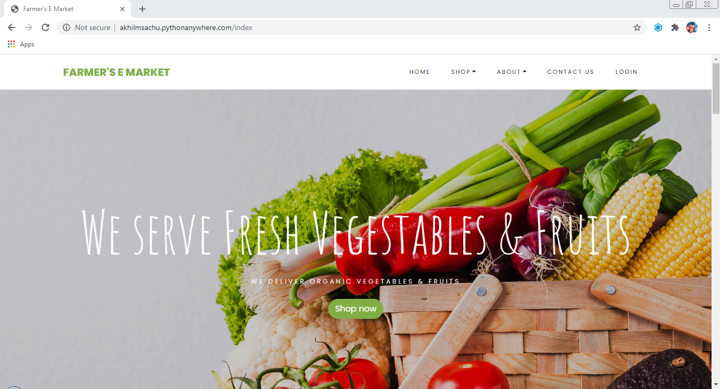

Fig 1: Index Page

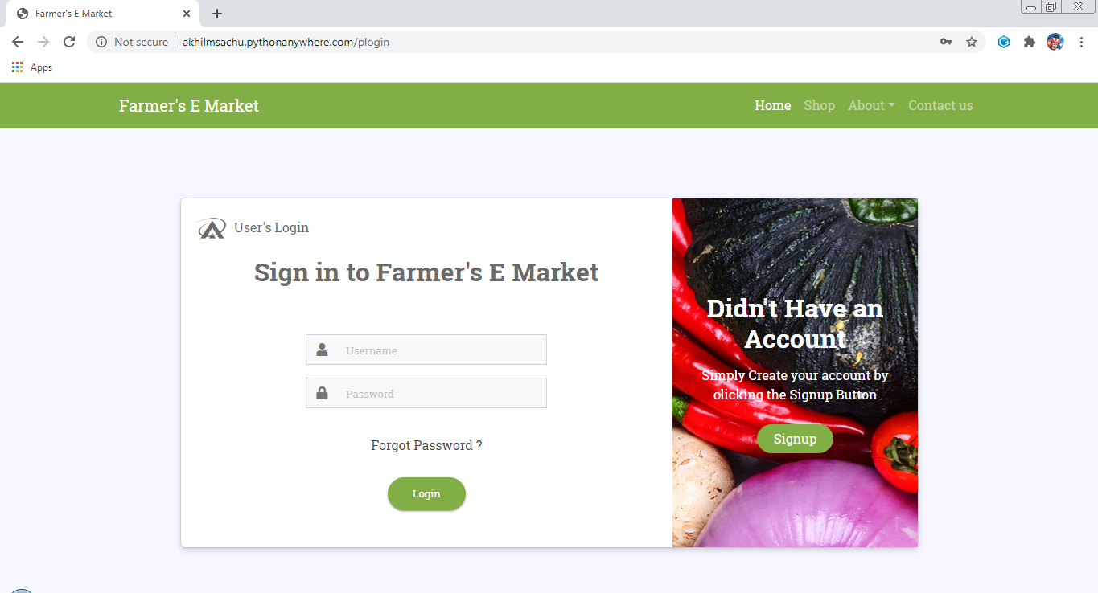

Fig 2: User Login Page

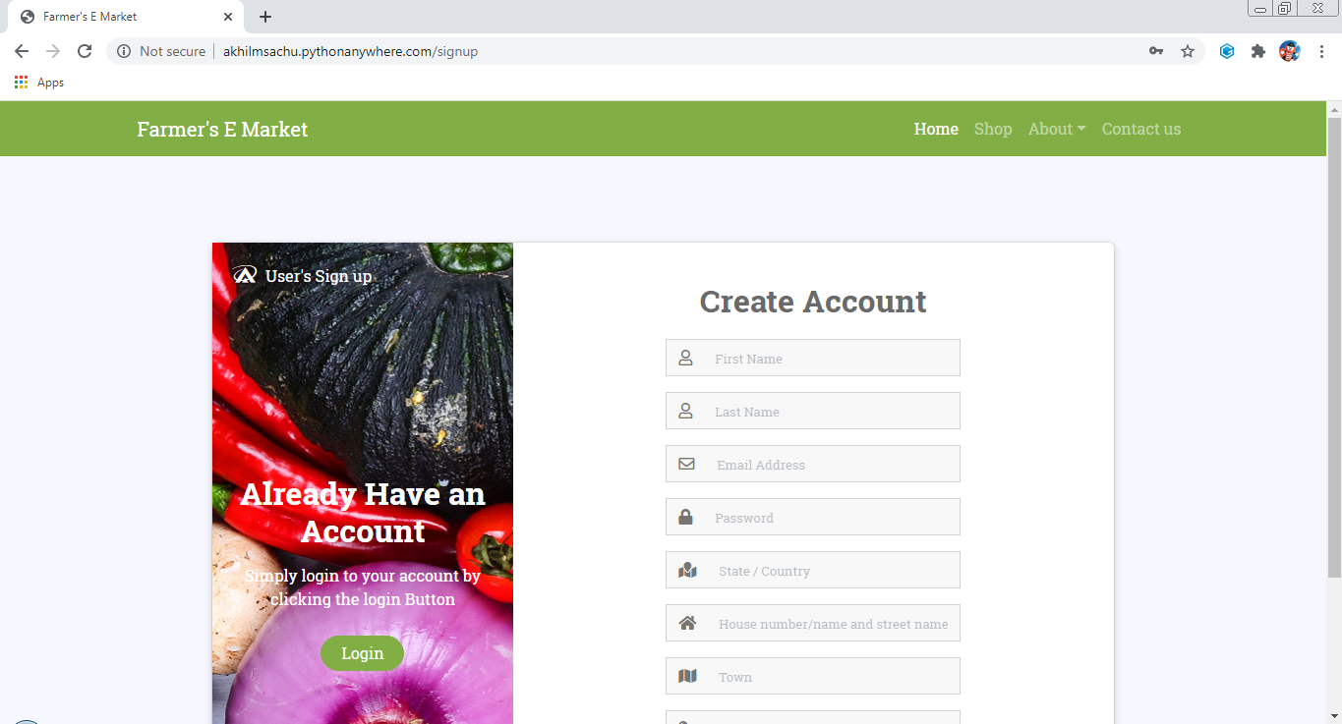

Fig 3: User Signup Page

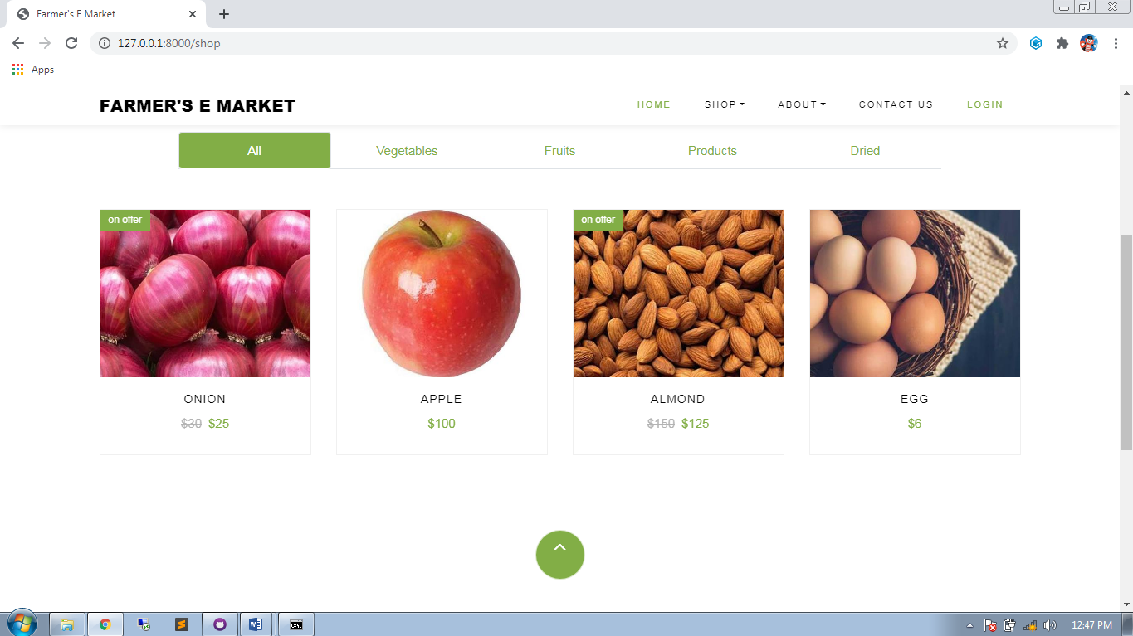

Fig 4: Shop Page

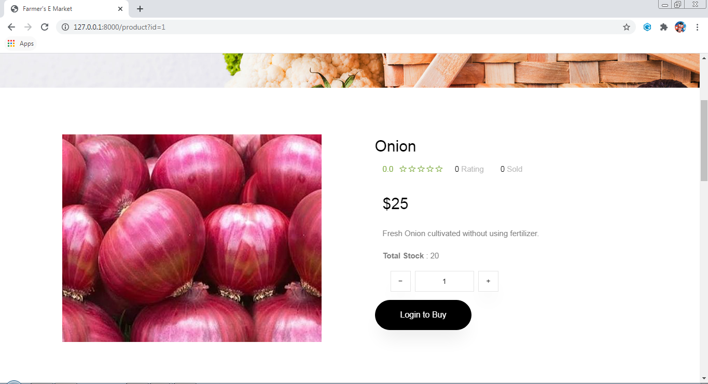

Fig 5: Product Page

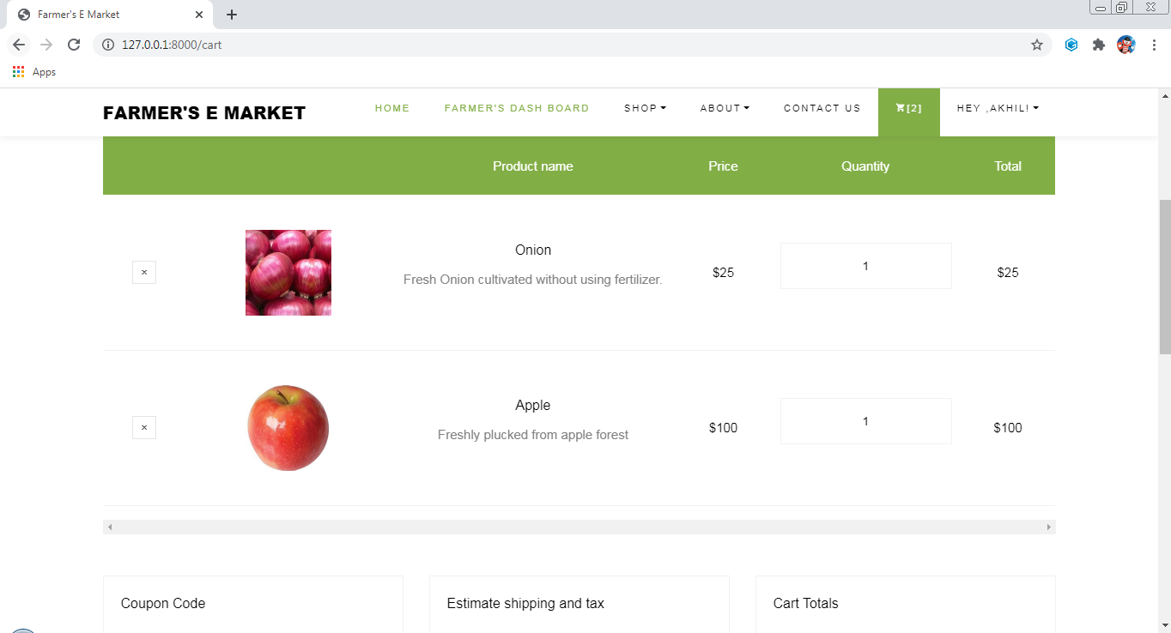

Fig 6: Cart Page

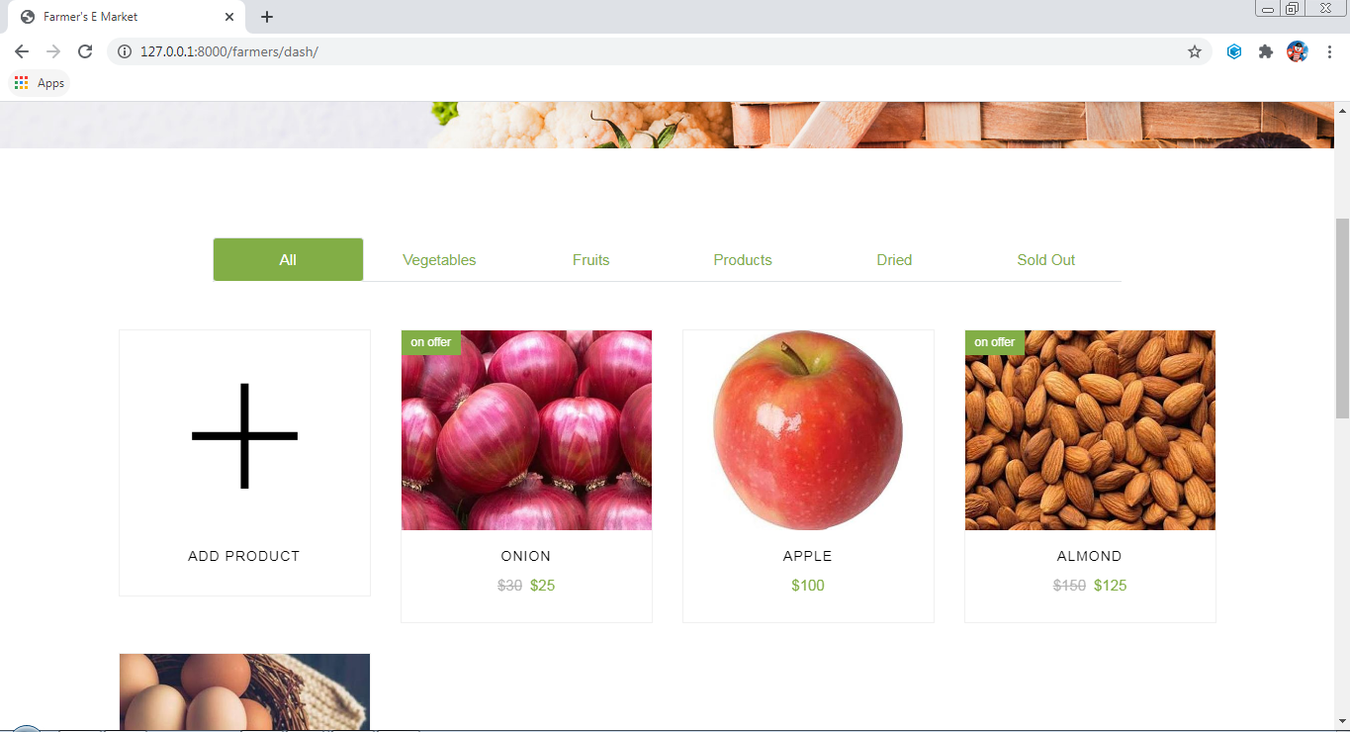

Fig 3: Farmers Dash Page

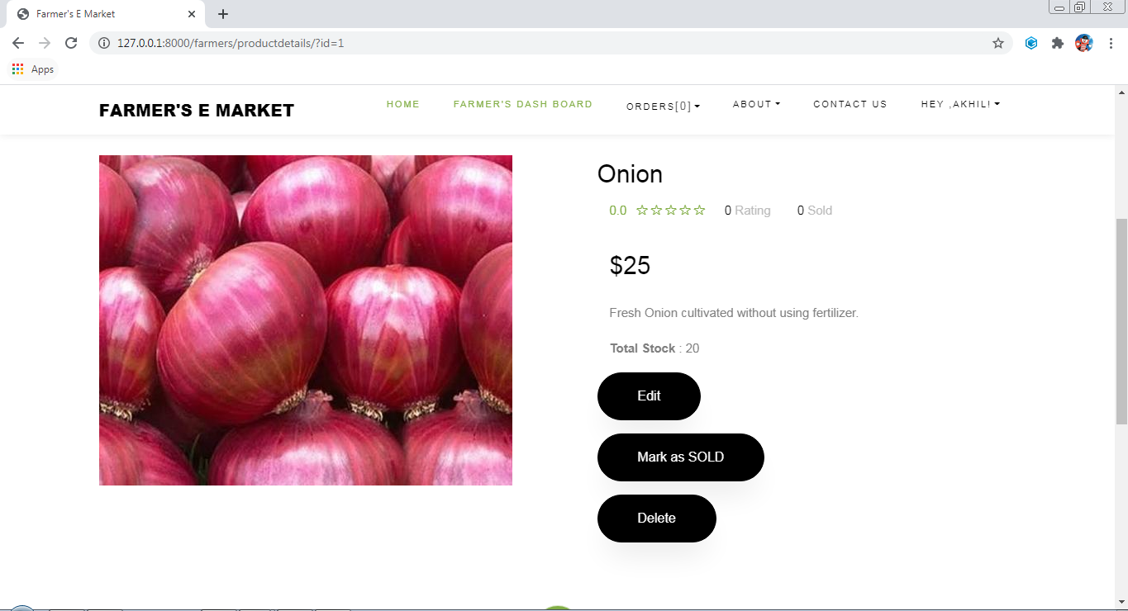

Fig 3: Farmers product Page

**BIBLIOGRAPHY**

**Internet sites**

1. <https://docs.djangoproject.com/en/3.0/topics/auth/default/#built-in-auth-forms>
2. <https://www.geeksforgeeks.org/django-url-patterns-python/>
3. <https://docs.djangoproject.com/en/3.0/ref/contrib/admin/>
4. <https://docs.djangoproject.com/en/3.1/topics/templates/>
5. <https://docs.djangoproject.com/en/3.1/topics/settings/>
6. <https://docs.djangoproject.com/en/3.1/howto/deployment/>
7. <https://docs.djangoproject.com/en/3.1/ref/contrib/staticfiles/>
8. <https://docs.djangoproject.com/en/3.1/topics/migrations/>
9. https://docs.djangoproject.com/en/3.1/intro/